Create a RAID 10 Array Using FreeNAS

Author: | Perry Whittle
Date: | 25th February 2010

Contents
1 Purpose Of the Document 3
1.1 Audience 3
2 Storage array types 3
3 Creating the array 4

Purpose Of the Document
This document explains how to create a RAID10 array using a FreeNAS Open source NAS\SAN box. This can be either a physical or virtual node. The example here utilises a VMWare ESX4i virtual machine. This array may then be presented over iSCSI transport to build a Windows 2003 or Windows 2008 cluster. For the purposes of this document the following apply

RAID | Redundant Array of Inexpensive Disks
OS | Operating System
Node | A host computer

Audience
The document is intended for engineers wishing to discover more about storage and RAID arrays. It is not expected that the reader is familiar with the FreeNAS OS or storage arrays but expects that FreeNAS is already installed and configured.

Storage array types
RAID arrays are sets of redundant disks, hence the name RAID (Redundant Array of Inexpensive Disks). RAID comes in various forms which have expanded since the appearance of more intelligent disk controllers. Common arrays are;

RAID 0 striped

Data is striped across disks, no fault tolerance.

RAID 1 mirrored

Data on disk is mirrored to a second disk

RAID 4 Striping with parity

One disk is dedicated for the parity bits, data is striped data across the remaining disks in the array.

RAID 5 Striping with parity

Stripes data including the parity bits across all disks in the array (distributed parity)

RAID6 Striping with Parity (dual parity)

Extra parity redundancy over RAID5

RAID 0+1 Striping with mirror

Striped set which is then mirrored

RAID 1+0 Mirror with striping

Mirrored disks which are then striped

Creating the array

Open the FreeNAS management page and go to Disk Management as shown below. We are going to be using the 4 disks 2GB in size.

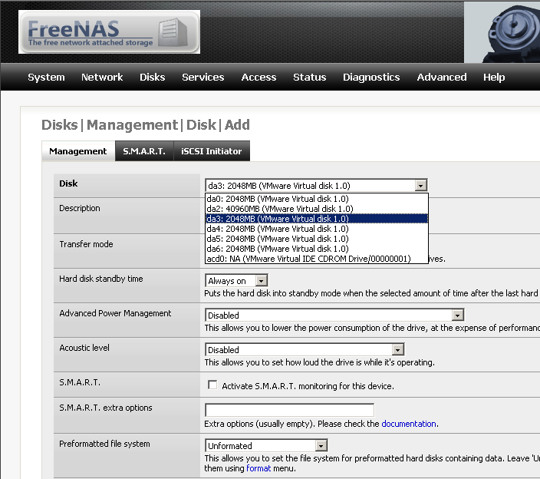

Add each disk in turn and be sure to click the drop down list box “Preformatted file system” and select “Software RAID” as the format type. Click “Apply changes”.

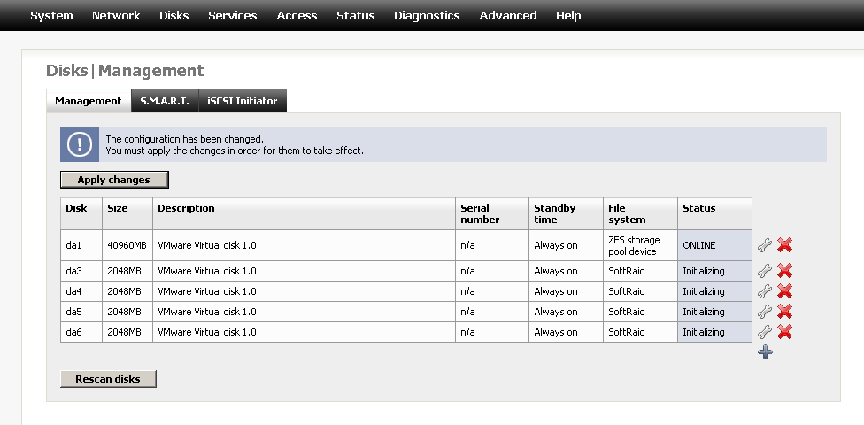
Using the 4 disks you just added, create the 2 RAID1 arrays (remember RAID10 arrays are mirrored and then striped). Shown below is the first RAID1 array, remember to “Create and initialize the array”. Click “Apply changes” before continuing.

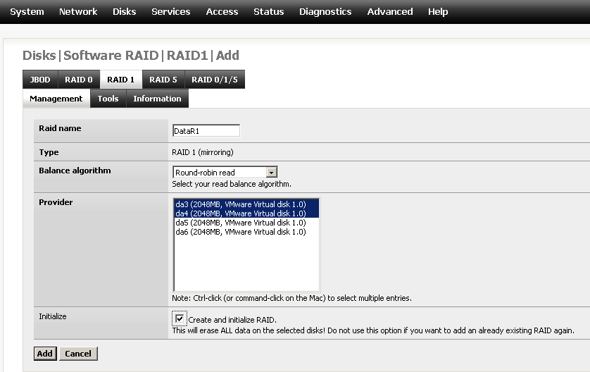

RAID1 arrays created! Both arrays should show the “COMPLETE” status.

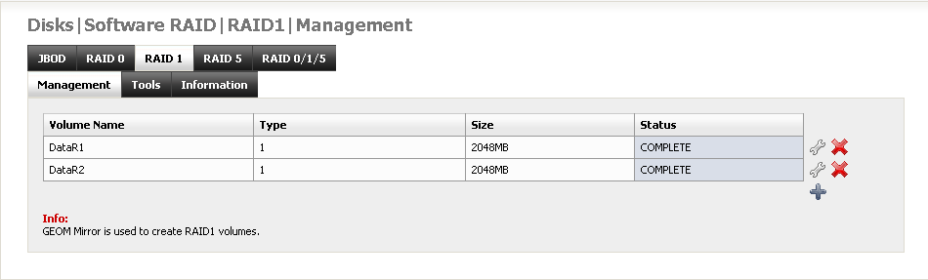

Format each of the RAID1 arrays from the “Format” menu shown below.

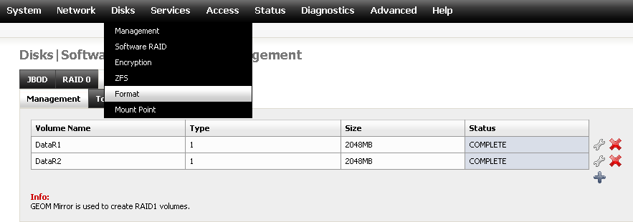

Format them as “Software RAID” as shown below.

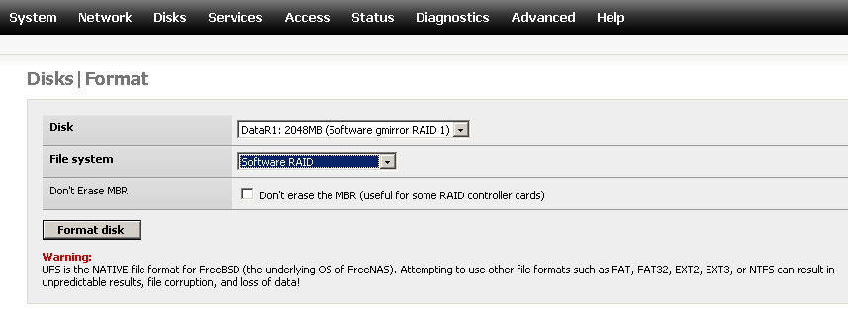

Now go to “Disks” then “Software RAID” from the menu and select “RAID0” as shown below. You will see the two RAID1 arrays previously created. Now we need to create a stripe across these arrays.

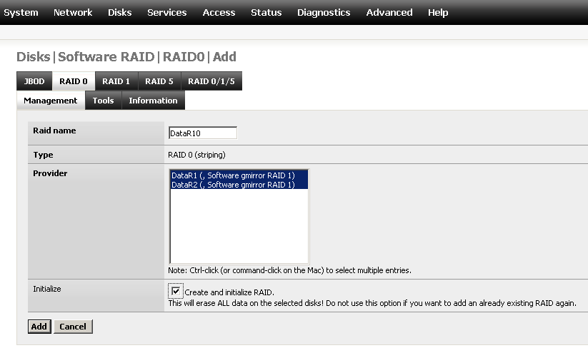
After adding the stripe and clicking “Apply changes” you should see the following.

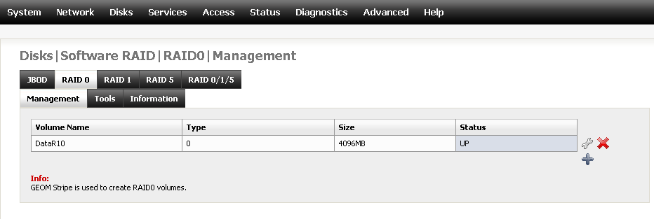

Now format your new array with the appropriate file system (UFS or ZFS). Add this as an iSCSI target and present to your cluster node!

