Create a 2 node virtual SQL Server 2005 Cluster Configuration

Author: | Perry Whittle
Date: | 26th January 2010

Contents
1 Purpose Of the Document 3
1.1 Audience 3
2 Clustering brief overview 3
3 CREATING THE WINDOWS CLUSTER 4
3.1 Create The Microsoft Distributed Transaction Coordinator Resource 36
4 INSTALLING THE SQL SERVER INSTANCE. 37
5 Appendix A Named Instances & network names 49
5.1 Non Clustered 49
5.2 Clustered 49

Purpose Of the Document
This document explains how to create a virtual 2 node SQL Server cluster using VMWare Server 2.0.1 (you could also use Microsoft Virtual Server 2005 R2 SP1), Windows 2003 Enterprise 32bit and SQL Server 2005 Enterprise 32 bit (you may 64 bit if desired). For the purposes of this document the following apply;

Fail-Over | A Microsoft Cluster implementation method
SSMS | SQL Server Management Studio
T-SQL | Transact_SQL (the native SQL Server command language)
MSCS | Microsoft Cluster Services. The underlying technology for SQL Server Fail-Over clustering
NIC | Network interface card
Virtual Server Name | A unique computer name in the domain. During fail-over this computername is passed from one node to another
Virtual IP Address | A unique IP Address in the network. During fail-over this IP Address is passed from one node to another
OS | Operating System
Node | A host which participates in a cluster
Quorum | The centralised repository used by MSCS
Heartbeat | A segregated private network for communication detection between nodes
Active\Passive | A cluster configuration which involves an active node and a passive node. The passive node becomes active on Fail-Over.

Audience
The document is intended for administrators wishing to simulate a SQL Server cluster environment for testing or as a tool when expressing a wish to learn more about Windows\SQL Server clustering. It is not expected that the reader is familiar with the Windows operating system and MSCS.

Clustering brief overview
MSCS involves 2 or more computers (they don’t have to be physical you can use virtual machines too) configured into a cluster relationship. This technology requires a central, shared storage (it cannot exist on the machine itself). Clusters use Virtual Server Names and Virtual IP Addresses to create a reference for the network connection to the clustered application. For example SQL Node 1 has a computername of SQLCLNODE01 and IP Address of 10.10.10.120. SQL Server instance INST1 has a computername of SQLCL01 and IP Address of 10.10.10.126. All network calls to the SQL Server instance 1 are made through the virtual server name and IP address, not the Nodes actual name or IP Address. During fail-over this virtual name and IP address are passed to the partner Node like a ticket, re directing network calls to the new Node.

CREATING THE WINDOWS CLUSTER

Install VMware Server 2.0.1 and then create the following folder structure locally

C:\

Virtual Machines

INST1
Quorum
DTC

Use the commands listed below to create the virtual disks required. The vmware-vdiskmanager.exe resides in the following folder if a default installation of VMware Server was used;

C:\Program Files\VMware\VMware Server

Open a command prompt and paste the commands, in turn, into the shell window (ensure you set the directory path first as shown in the screenshot below).

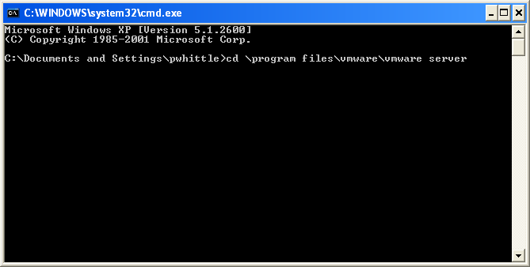

Create the drives as shown below

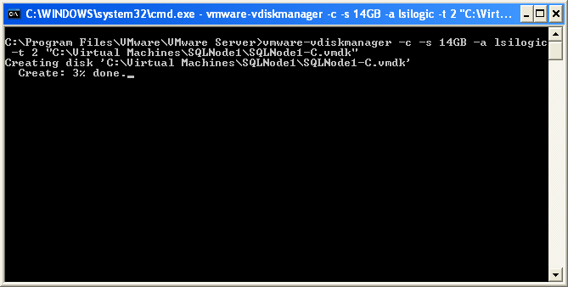

Create the quorum drive

vmware-vdiskmanager -c -s 512MB -a lsilogic -t 2 "C:\Virtual Machines\Quorum\Quorum.vmdk"

Create the drives for the SQL Server clustered instance data, logs and DTC

vmware-vdiskmanager -c -s 5GB -a lsilogic -t 2 "C:\Virtual Machines\INST1\INST1_Data.vmdk"

vmware-vdiskmanager -c -s 5GB -a lsilogic -t 2 "C:\Virtual Machines\INST1\INST1_Logs.vmdk"

vmware-vdiskmanager -c -s 2GB -a lsilogic -t 2 "C:\Virtual Machines\DTC\DTC_Data.vmdk"

Ensure you add your Windows domain\local account to the following local group on your pc

__vmware__

Log into the Vmware Server console supplying your Windows account and password and you will see the following;

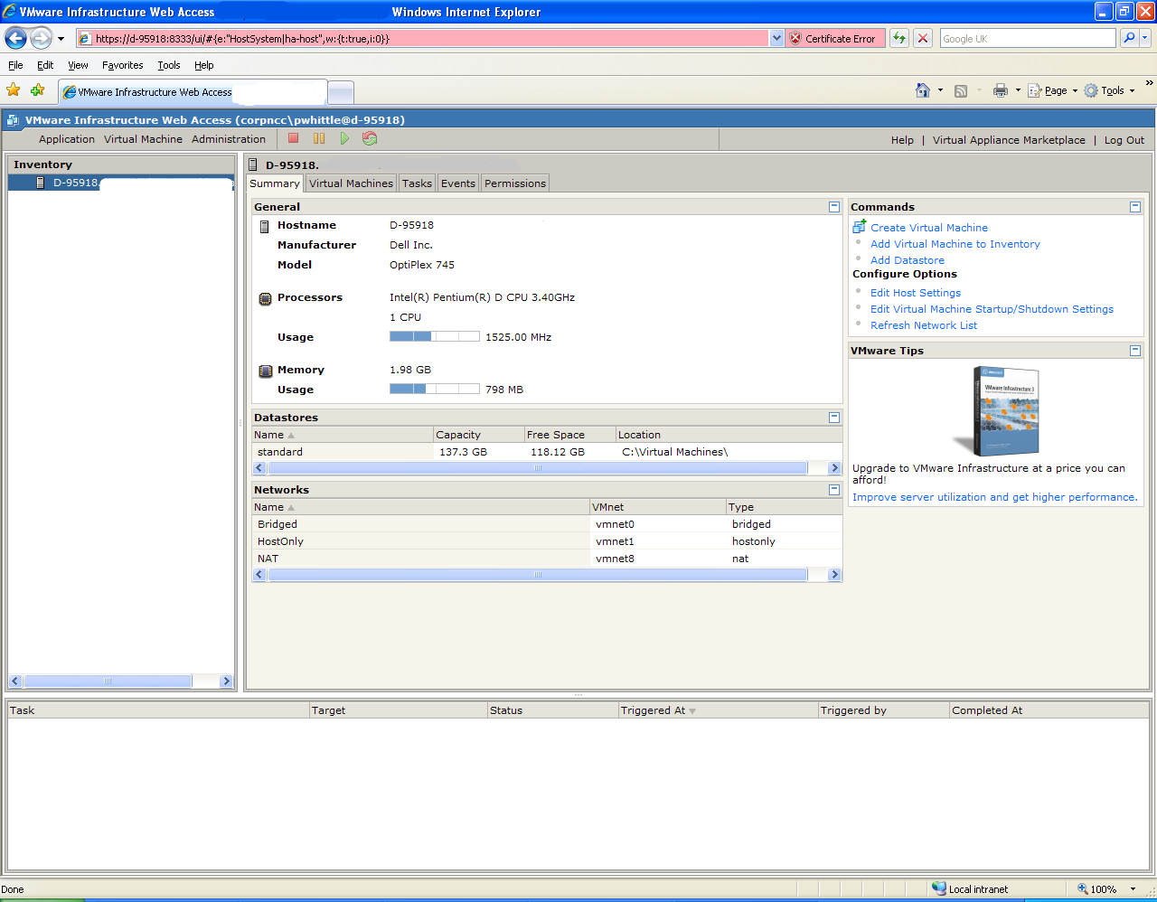

Open the VMWare “manage virtual networks” option from the Start menu. Go straight to the “Host virtual adapters” tab and add a new virtual adapter for VMnet2 and click “Apply”

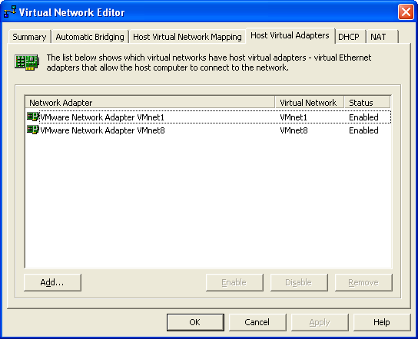

Now go to the DHCP tab and remove any DHCP assignments (click each item and remove) the click “Apply”.

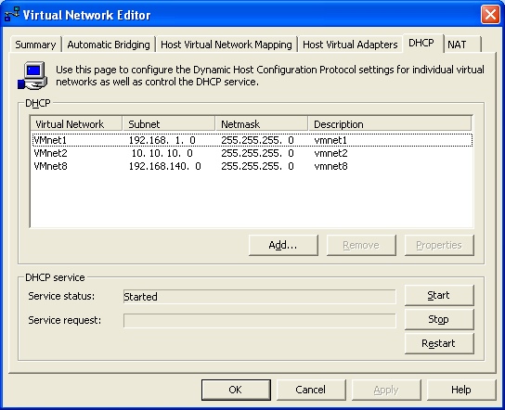
Go to the “Host virtual network mapping” option and change the subnets to be used for VMnet 1 & 2. Do this by clicking the arrow (indicated) and selecting “Subnet” from the pop-up menu

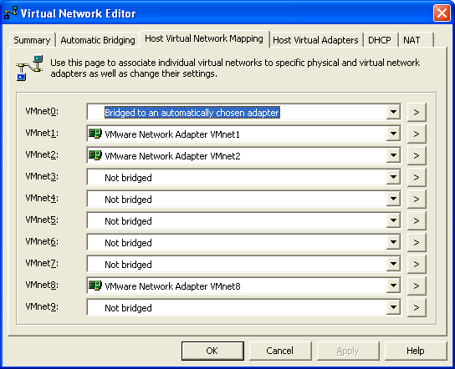

For VMnet1 set the IP address to 192.168.1.0

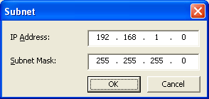

For VMnet2 set the IP address to 10.10.10.0

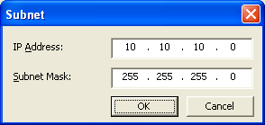

Click “OK” to exit the virtual network editor.It’s a good idea to open your host machine network connections and rename the virtual LAN adapters to something a little more meaningful;

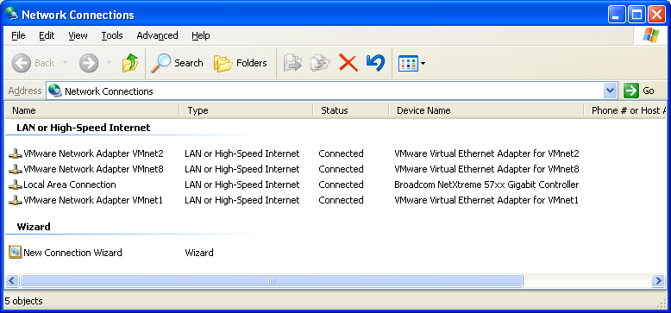

Renamed to

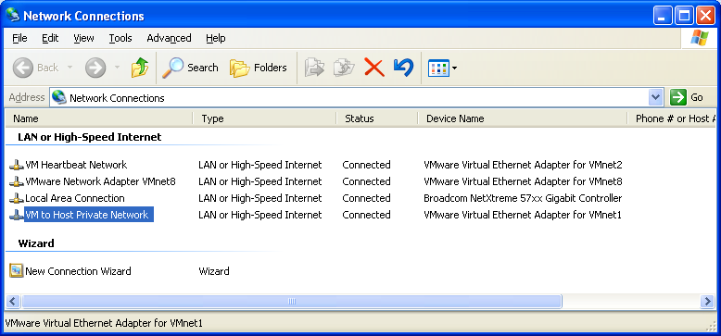

Click the “refresh networks list option” within the VMWare Server console to refresh the virtual networks.

With the VMware Server console installed and configured and the virtual networks and hard disks created, it’s now time to create a datastore to hold all the ISO images we wish to install from.
Select the host node in server console as shown below and under “Commands” click “Add datastore”;

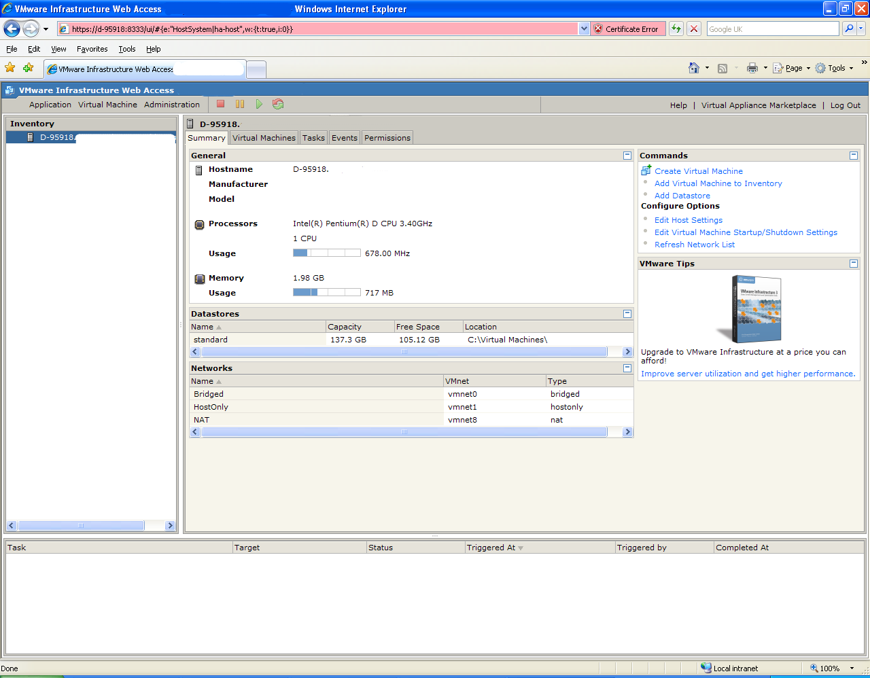

At the dialog supply a datastore name (ISOs) and a local path (C:\ISOs) then click “OK”;

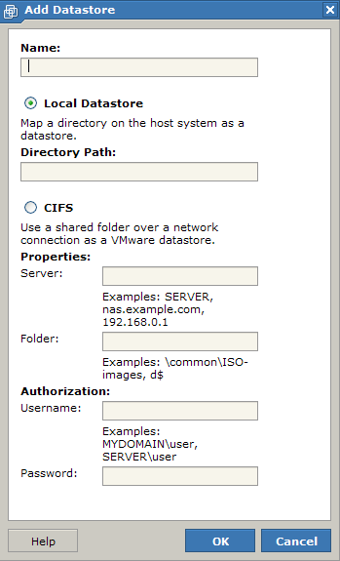
Now we are ready to start creating the VM’s. Under the “Commands” section, select “Create virtual machine”. Enter a Virtual machine name and select a datastore (this datastore maps to a folder on your local drive) then click “Next”;

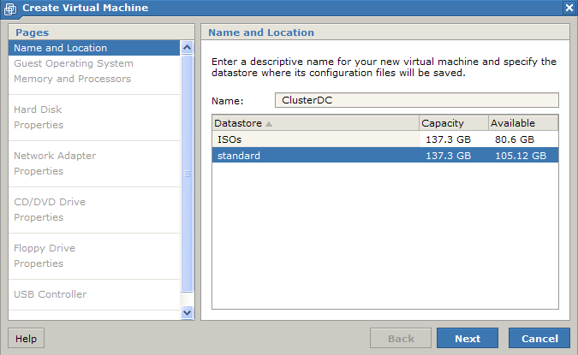

Select the Operating System type (Enterprise Edition for clustering. We will be using 32bit OS) and click “Next”;

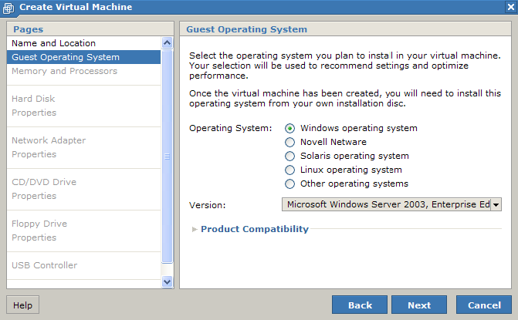

Select the RAM (256Mb for DC and 400MB for each cluster node) and CPU (1 each) then click “Next”;

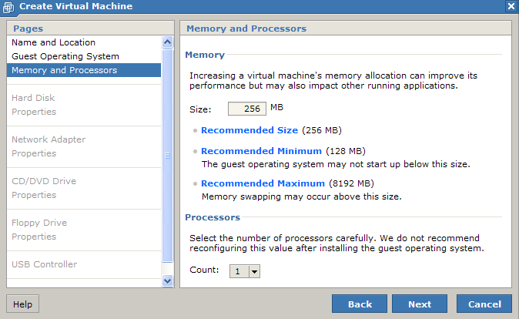

Select to create a new virtual disk;

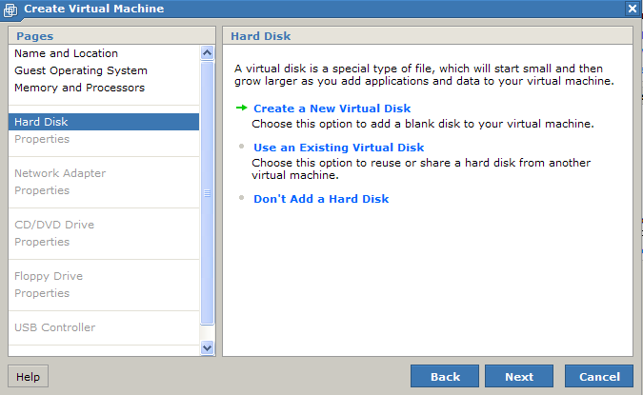

Supply a size for the virtual disk and select SCSI bus (SCSI ID 0 for the VM boot drives in our example). Click “Next”;

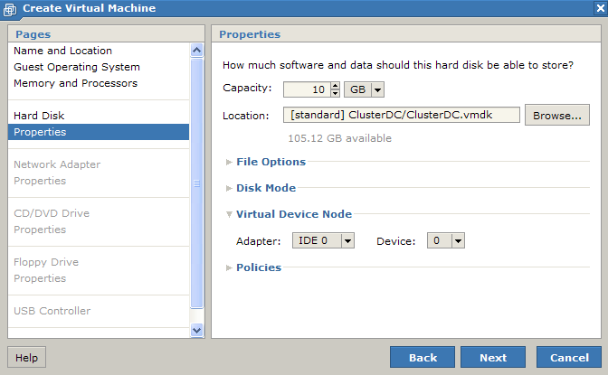

Select “Add a network adapter” and the network selection browse opens

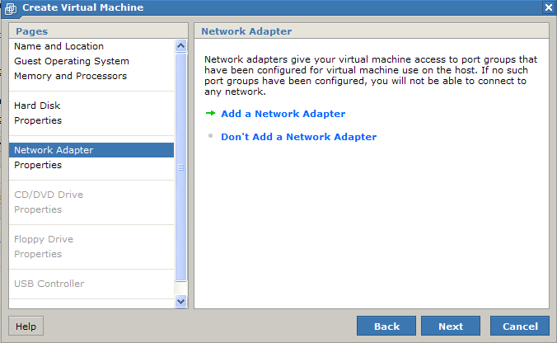

Select “Host only” for this vNIC and click “Next”;

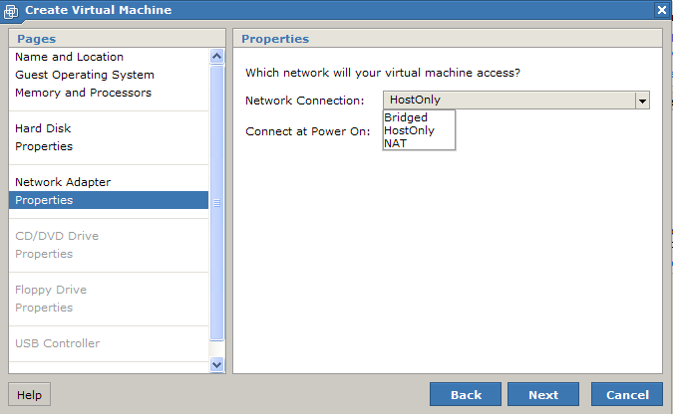

Select to use an ISO image for the vCD drive and click the browse button,

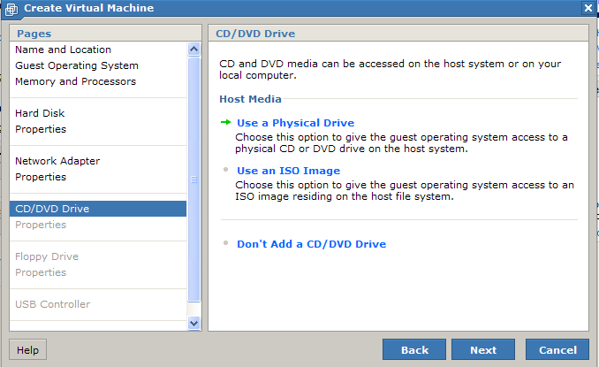

The datastore browser opens, drill down and select the Windows 2003 R2 Enterprise ISO and click “OK”. At the “create virtual machine window” click “Next”;

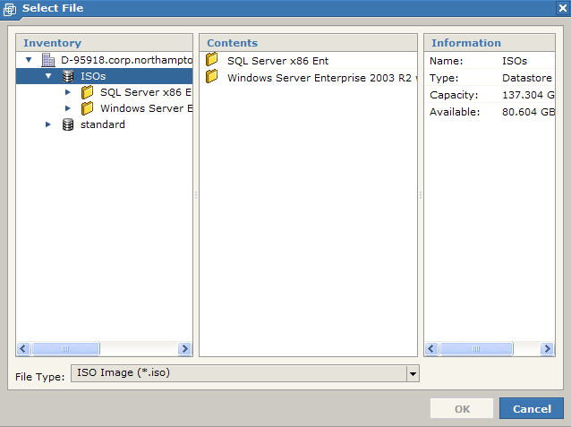

At the next screen do not add a floppy drive and click “Next”;

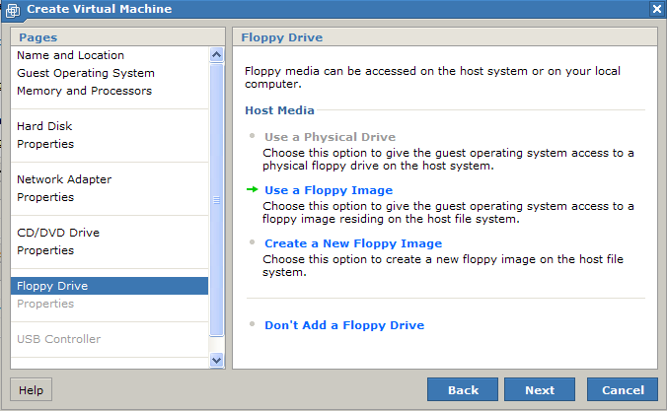

Do not add a USB controller and click “Next”;

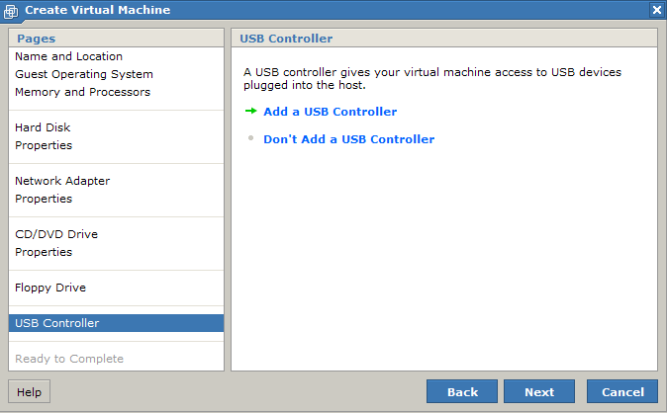

At the last screen click “Finish” to complete the VM

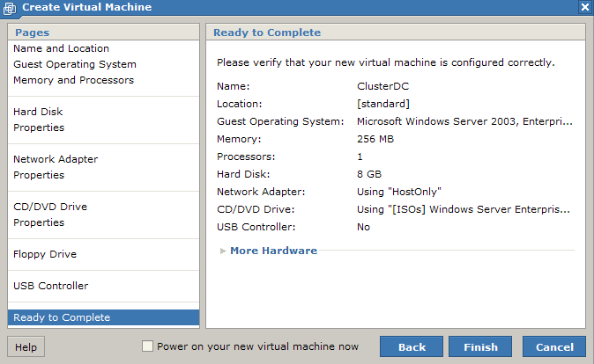

Create the remaining VMs (node 1 and node 2). For each of the cluster nodes add a second vNIC, this will be used for the Heartbeat network. This is done as follows;

Select the first node and under the “Command” section click “Add hardware”, the following screen appears. Click “Network adapter” and the vNIC properties appear;

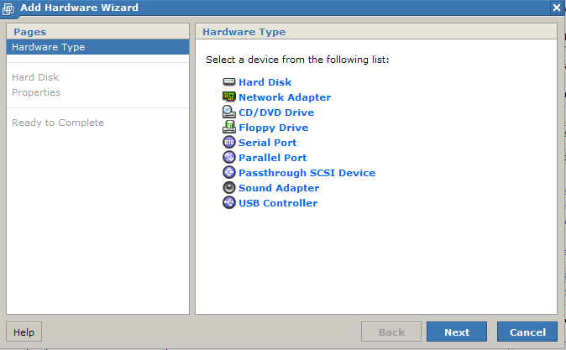

Select the “VMnet2” option from the drop down list and click “Next”, then click “Finish” to complete. Do this for the second cluster node too.

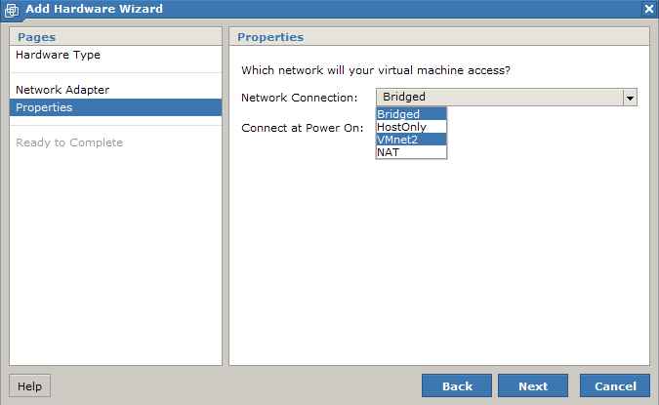

Install the windows operating systems on each VM and create a domain controller with a test domain on ClusterDC. Configure networking (Public and Heartbeat) between the 3 VM’s and join the 2 nodes to the domain. Once this is done you may proceed with the rest of the instructions in this document.

Once the cluster nodes have been created we need to shut the VM’s down and attach the pre created virtual disks to each cluster node this involves also manually editing the VM configuration file (*.vmx). With the VM’s powered off start as follows.
Select node 1 and click “Add hardware”. Click “Hard disk”;

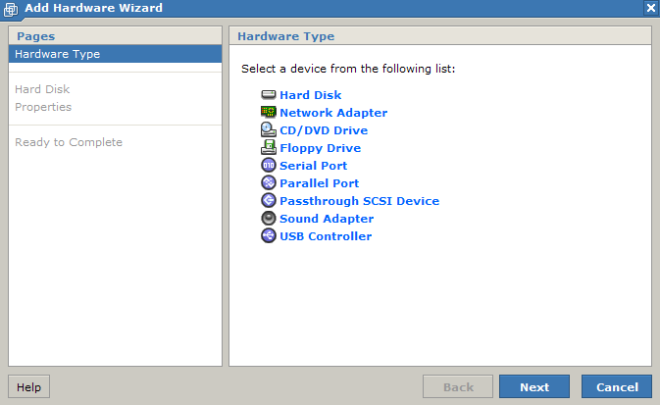

Use existing hard disk;

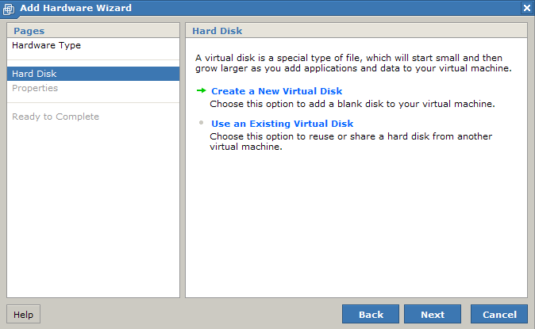

Click the “Browse” button;

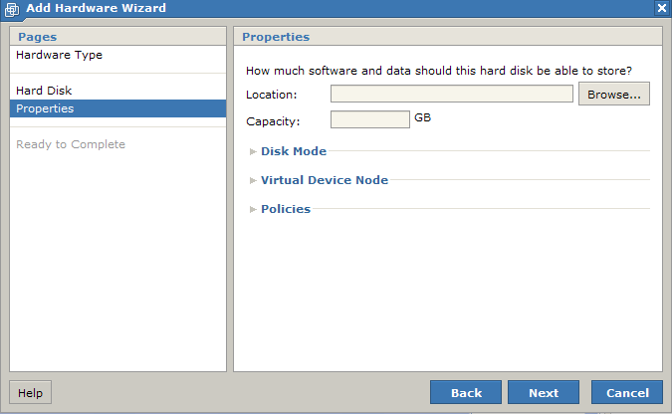

The datastore browser opens. Select the first disk “Quorum” and click “OK”;

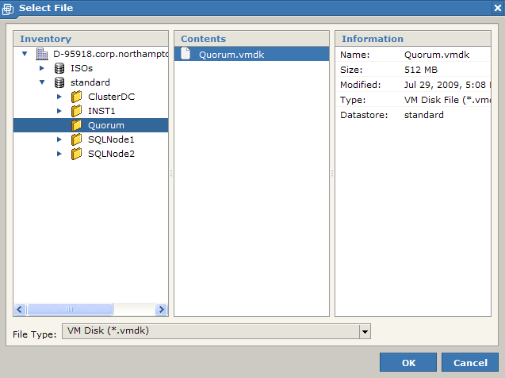

Under the “Virtual device node” settings accept the default assignment for node1 if you used an IDE boot drive. If you chose a SCSI bus boor drive change the adapter below to SCSI Bus 1. Click “Next”;

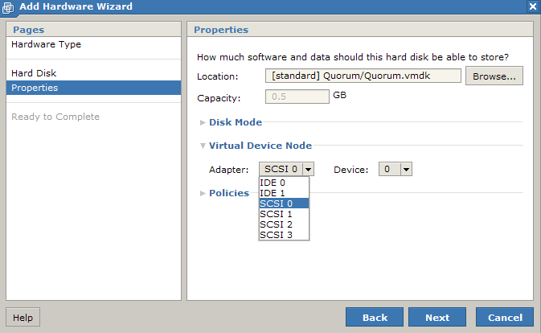

At the next screen select the “More hardware” option to add the 2 remaining SCSI disks.

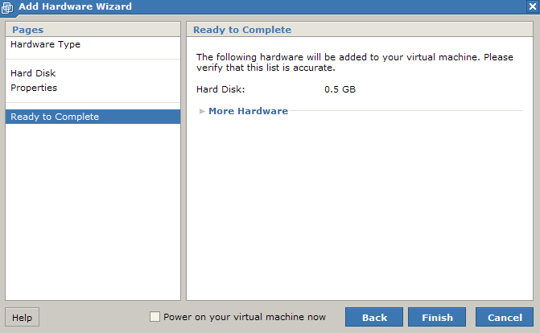

Eventually you will see, click “Finish” to complete the configuration;

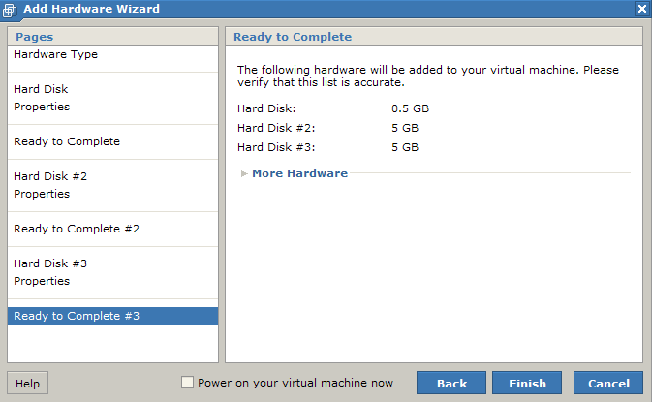

Now do the same for Node 2.

Once the disks have been added to both VM’s it is important that only 1 machine is booted at any one time until the Windows cluster is installed and configured on the first node otherwise disk corruption will occur. The final step remaining is to ensure that the virtual SCSI bus on each VM is set to share and disk locking is disabled. Edit the .VMX file for each node by clicking the virtual machine and then under commands click Configure VM. On the advanced tab click into the Configuration Parameters section and then click Add New Entry using the following;

Name = disk.locking
Value = false

Click “Apply” and “OK” to finish configuring the VM. Do the same for the second node.
Next locate the VM configuration (search for *.VMX) file for each node, open in NOTEPAD and find the following section;

scsiX.sharedBus = "none" where X is the SCSI bus number the shared disks are attached too (1 in our case).

Change the text to;

scsiX.sharedBus = "virtual"

Close the file and save it.

Now the bus has been shared on both nodes, we need to power on the first node and in disk management create the NTFS partitions on each of the 3 disks. Also configure an IP address and subnet mask only on the heartbeat NIC. Select TCP\IP advanced properties and on the DNS tab clear the checkbox “Register this connections address in DNS”. In network connections explorer change the adapter order to Public first then Private\Heartbeat.

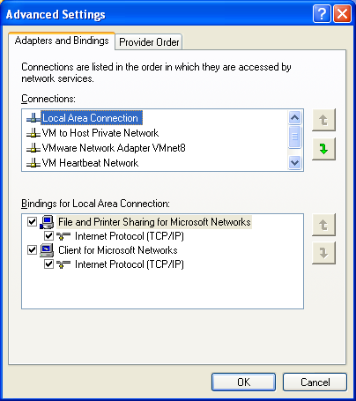

Highlight the connection and click the up or down arrow to move. Ensure the Public connection is topmost

Boot the first node and create 3 NTFS partitions on the 3 new drives, use drive letters Q (Quorum), S (SQL Data) and T (SQL Logs). Although not necessary on your virtual machines the following instructions are used to create aligned partitions for use with SQL Server.
Open a command prompt and type diskpart followed by return as shown below

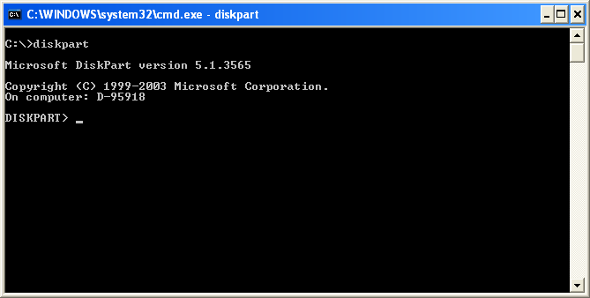

Now select the correct disk ID number (you may get these from disk management), our example is 1.

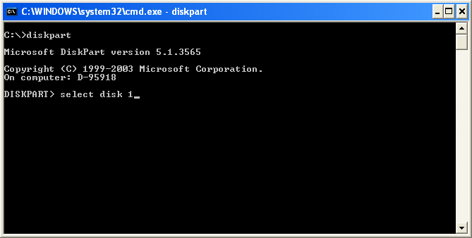

Now issue the command to create the partition shown below

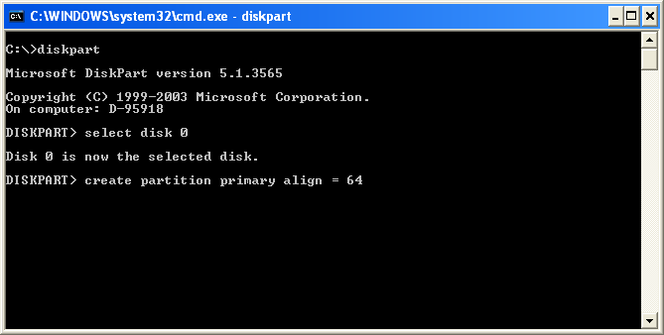

Once the partition has been created assign a drive letter using the following

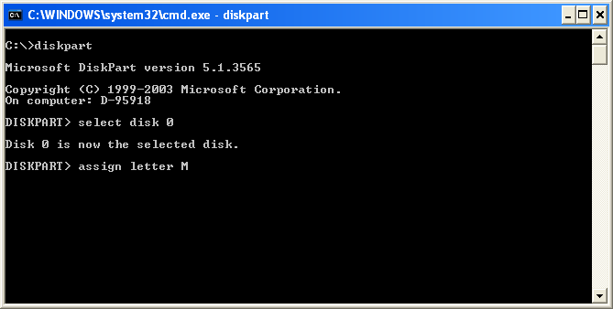

Now type exit to quit diskpart and at the command prompt format the partition using

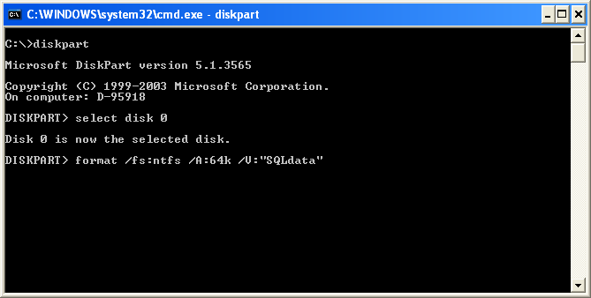

The partition will be created using the label SQLData and NTFS file system with a cluster size of 64kb. (Note that NTFS disk compression will be disabled on this partition).

Create a simple text file on each drive. Shutdown the first node and boot the second node. Open disk management and assign the drive letters to the 3 raw disks. Check the text files exist, if they do then all is well. If you cannot view the files drive corruption has occurred and you should re create the virtual disks (remove them from the VM’s first).

Now we need to install and configure the first node into the new cluster, shutdown Node2. Boot the first Node and open cluster administrator and select the option to create a new cluster;

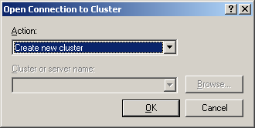

Click “Next” at the welcome screen;

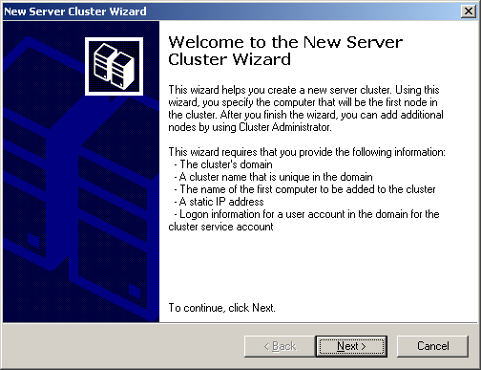

Select the domain and enter a unique cluster name, then click “Next”;

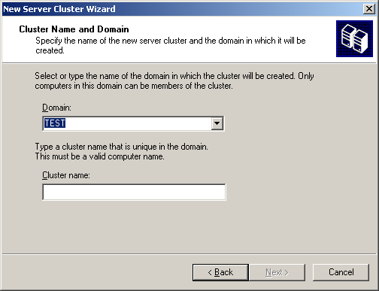

Confirm the node to add to the cluster and click “Next”;

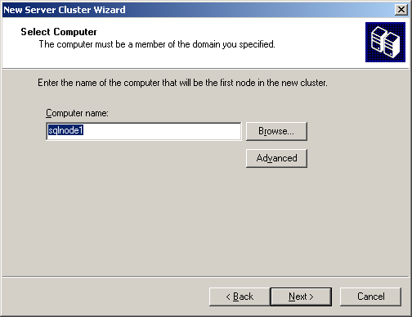

Review any errors or warnings from the analysis stage and click “Next” to proceed;

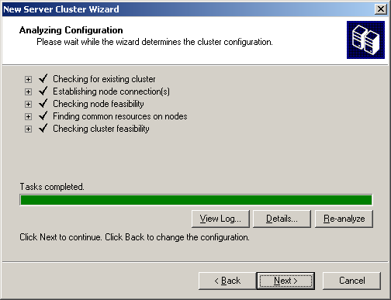

Enter a unique IP Address for the cluster and click “Next”;

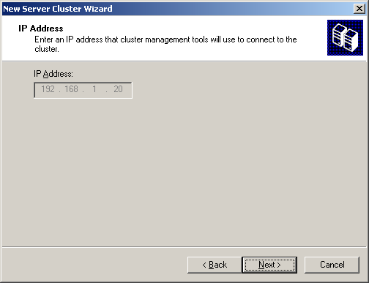

Enter the cluster service account credentials and click “Next”;

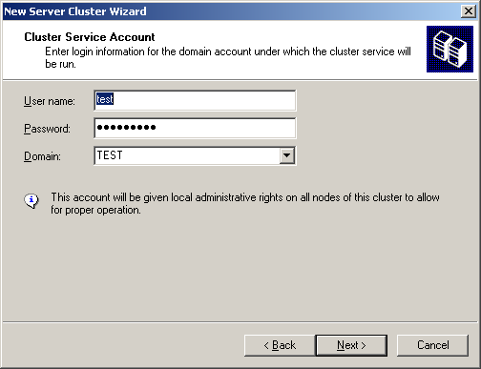

Review the proposed configuration and click “Next”;

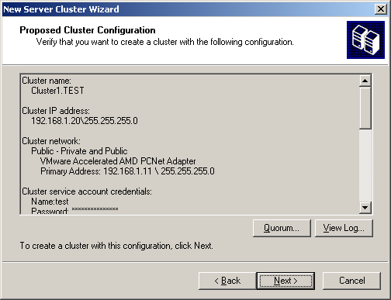

Once the cluster has been configured review any errors or warnings and click “Next” to proceed;

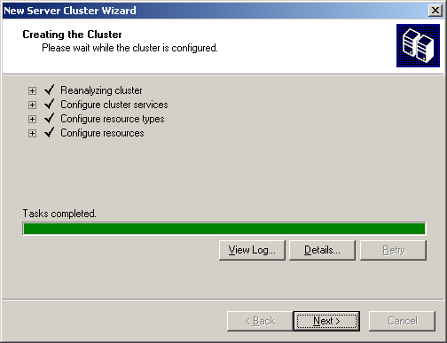

Finally click “Finish” to exit;

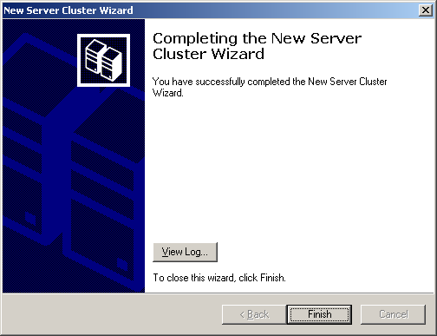
Now the first cluster node is active and managing the resources you may now boot SQLNode2. From within inside cluster administrator on SQLNode1, right click the cluster and select new > node and the add node wizard will start.

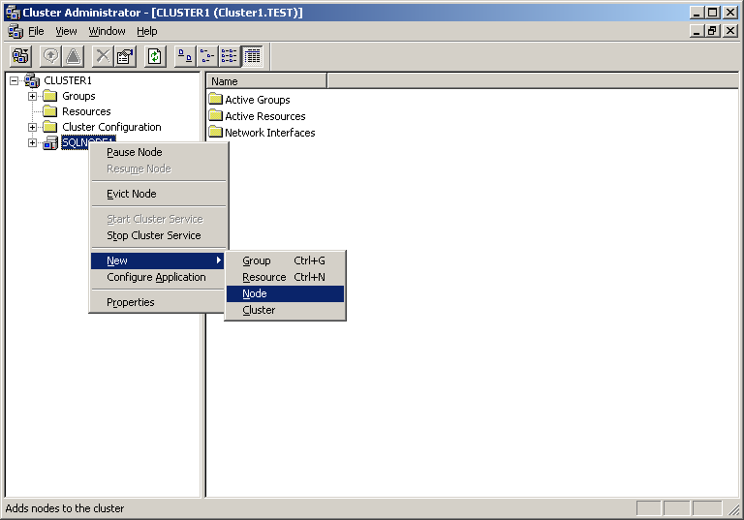

Click “Next” through the welcome screen and you will be asked to provide the computer name of the node you wish to add. Browse for the computer name and select from the list returned. Click the “Add” button to confirm the node;

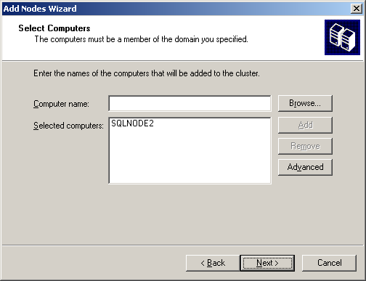

For the add node action use a minimal configuration by clicking the advanced button. Click “Next” to proceed

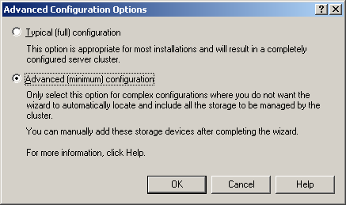

Cluster administrator analyses the configuration, review any errors or warnings.

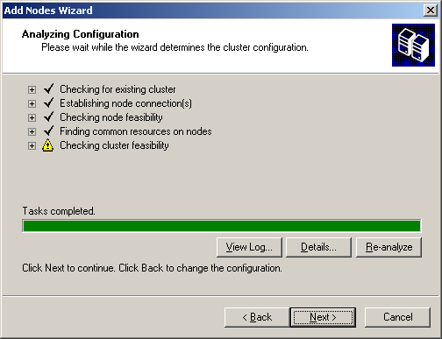

Supply the cluster service account credentials

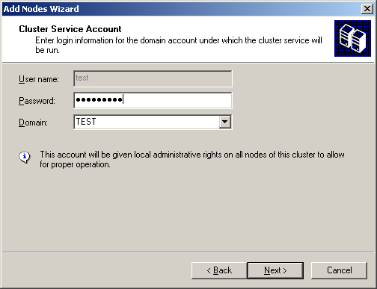

Review the proposed configuration and click “Next”;

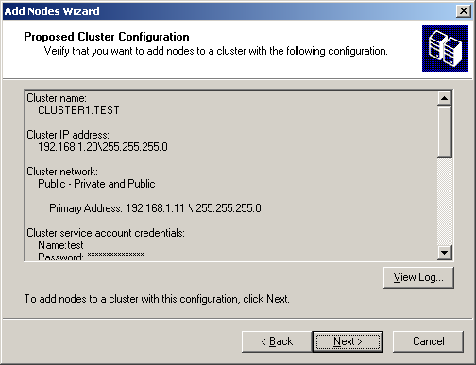

The node(s) is\are added to the cluster, again review any errors or warnings

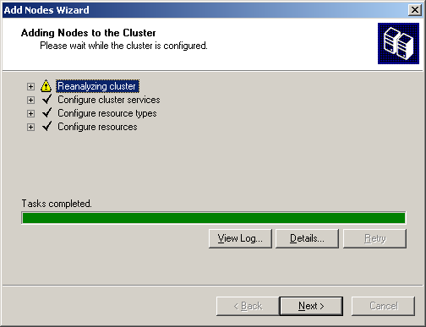

Finally click “Finish” when the wizard has completed;

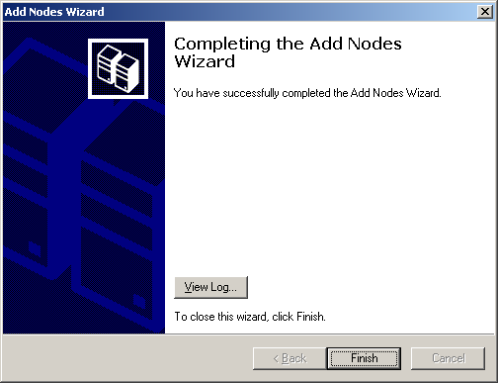

Now the cluster has both nodes configured you should see the following in cluster administrator. Notice all resources owned by SQLNode1

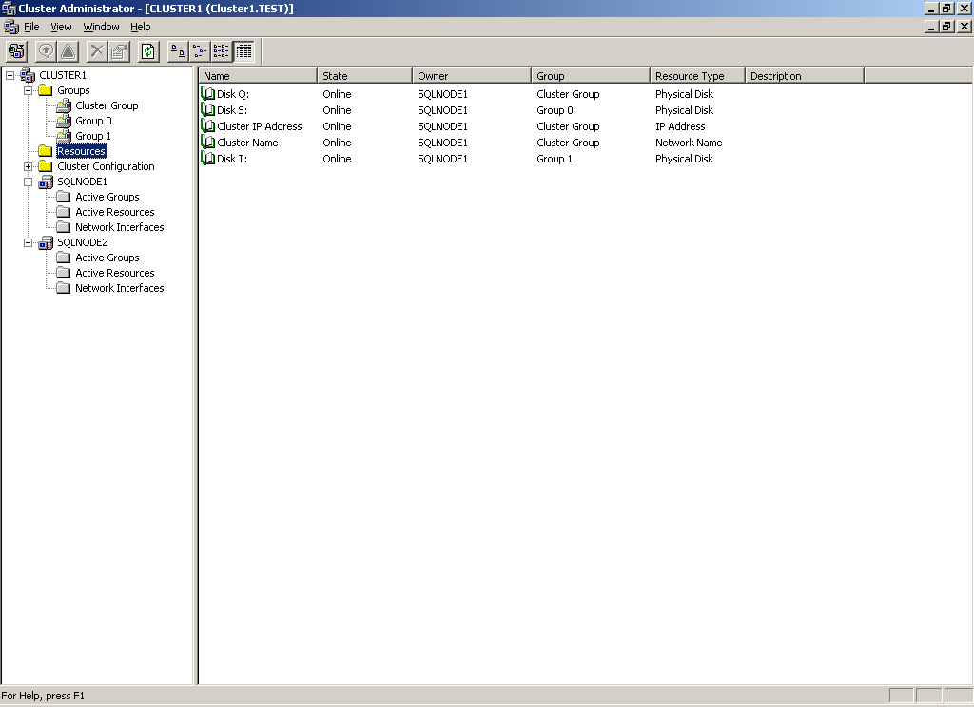

Open the networks information and set the properties for each item;

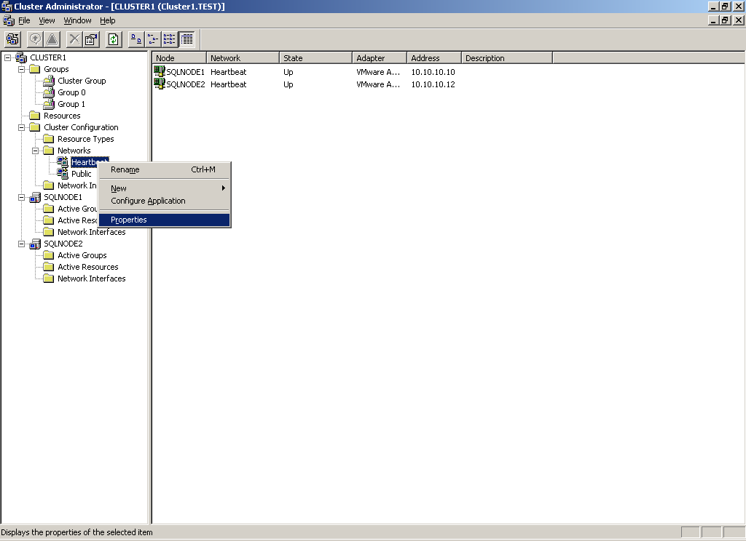

The Heartbeat needs only internal access;

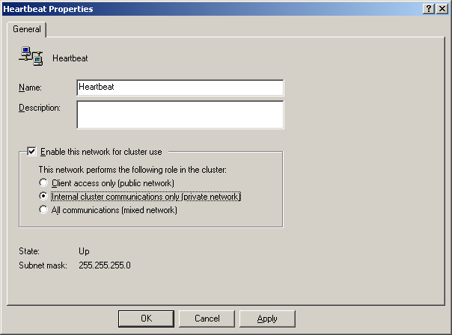

The Public should be set to Mixed Communication access;

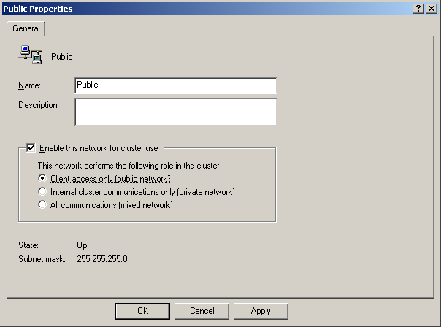

Test your cluster configuration by moving a cluster group from one node to another. Right click a group and select “Move group”. The resource will transfer to the partner node;

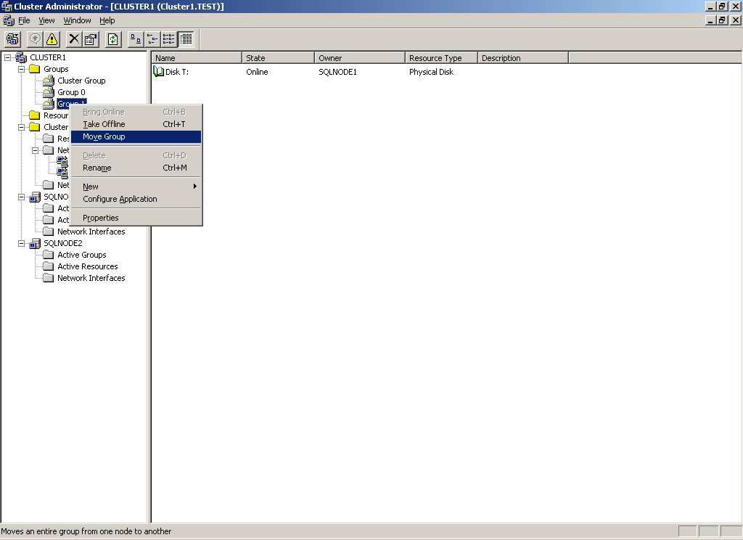

Groups 0 and 1 transferred to SQLNode2;

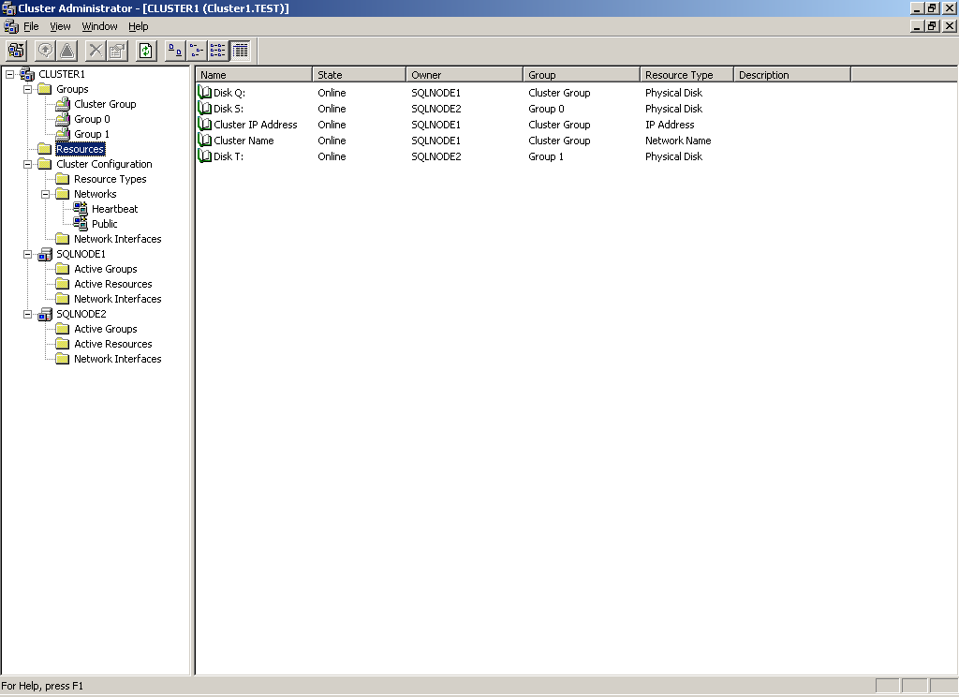

Create The Microsoft Distributed Transaction Coordinator Resource

Next we need to create a cluster resource and group for the Distributed Transaction Coordinator service.

In Cluster Administrator right click ‘Groups’ and select ‘New’ > ‘Group’. Give the group a name and click ‘Next’ then add available nodes and click ‘Finish’.
Right click the newly created group and select ‘New’ > ‘Resource’. Give the resource a name ‘INST1DTC IP’, from ‘Resource Type’ drop down list select ‘IP Address’ and click ‘Next’. Select available nodes and click ‘Next’. Click ‘Next’ through dependencies, enter an IP Address and mask for the public network (192.168.0.30 and 255.255.255.0) and click ‘Finish’.

Right click the group and select ‘New’ > ‘Resource’. Give the resource a name ‘INST1DTC Name’. From the drop down list select ‘Network name’ as the resource type and click ‘Next’. Select available nodes and click ‘Next’. Add IP Address resource as a dependency and click ‘Next’. Enter the unique network name and uncheck the ‘DNS registration must succeed’ checkbox then click ‘Finish’.

If the DTC disk drive has already been discovered by Cluster Administrator you may skip this paragraph. Otherwise, right click the group and select ‘New’ > ‘Resource’. Give the resource a name ‘DTC Data’ and from the drop down list select ‘Physical Disk’ as the resource type, then click ‘Next’. Select available nodes and click ‘Next’. Click ‘Next’ through the dependencies. From the drop down list on the parameters dialog select the disk drive to use (P:) then click ‘Finish’.

Lastly create the DTC resource by right clicking the group and selecting ‘New’ > ‘resource’. Give the resource a name ‘INST1DTC SVC’ and select ‘Distributed Transaction Coordinator’ from the ‘Resource Type’ drop down list, then click ‘Next’. Select available nodes and click ‘Next’. At the dependency dialog select the resources for Network Name and Physical Disk only (These resources must be online for the service to start) then click ‘Finish’. Now right click the group and bring it online.

INSTALLING THE SQL SERVER INSTANCE.
Once the cluster has been created and configured you may then proceed to install the SQL Server instance. This is done as follows, at the splash screen select to install the SQL Server components;

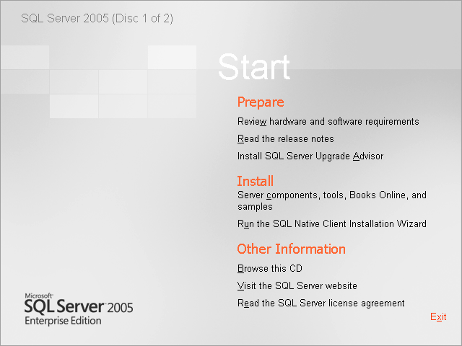

Accept the EULA and click “Next”;

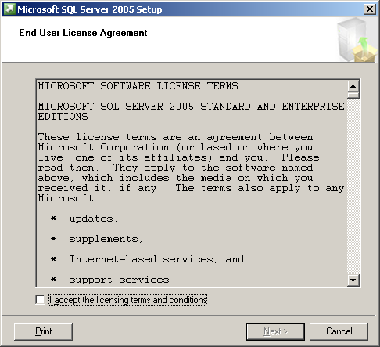
Click “Next” to install the SQL Server support files and .NET Framework

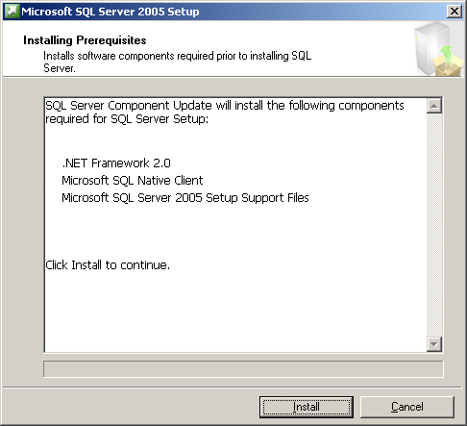

Click “Next” to continue;

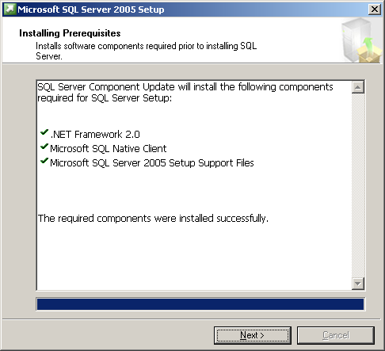
Click “Next” to the Welcome dialog

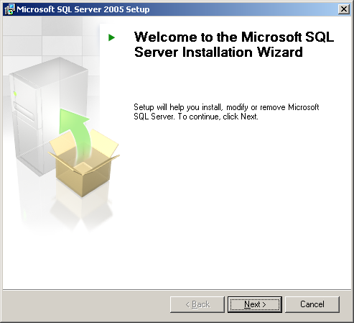

Click “Next” to the complete the System Configuration Check. Review any errors or warnings (IIS is only required for Reporting Services installations so ignore this)

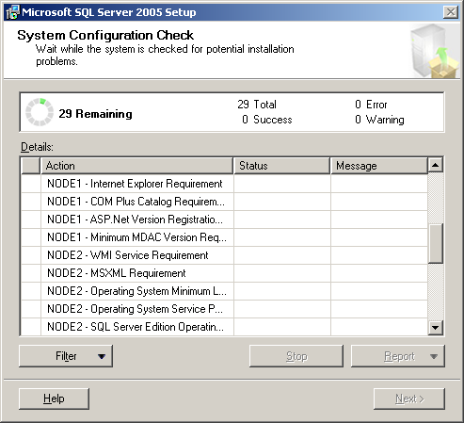
Click next to proceed past the licence details (the product is pre-pidded)

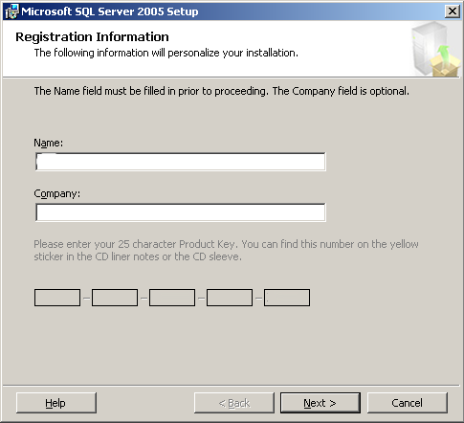

Select the options to install, note the option for a fail over cluster (select this now). Click “Next” to proceed

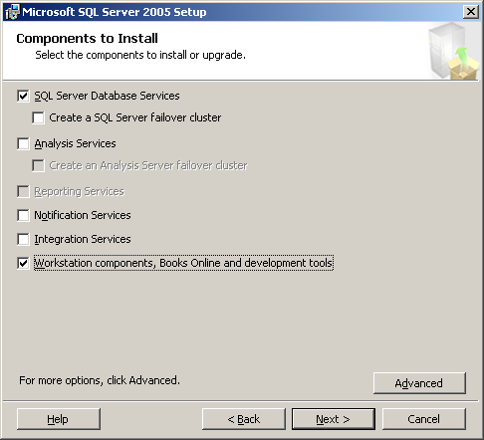
Supply an instance name and click “Next”

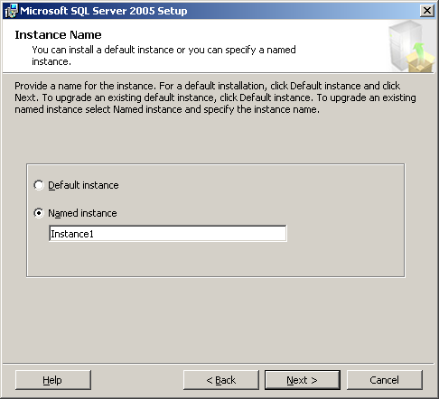

Supply a unique Virtual network name. For more info on network names and named instances see Appendix B.

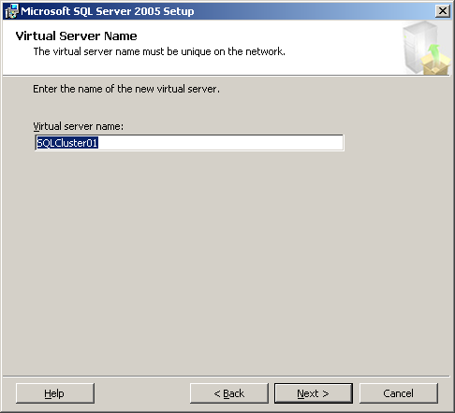
Enter an IP Address for the virtual network name and click “Add”.

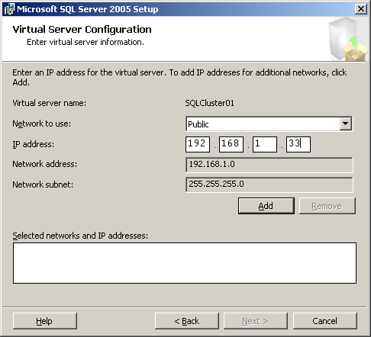

Then click “Next” to proceed

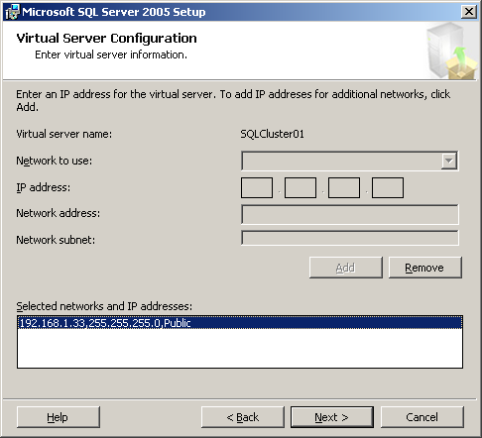

Select the cluster Group that contains the resources you wish to use;

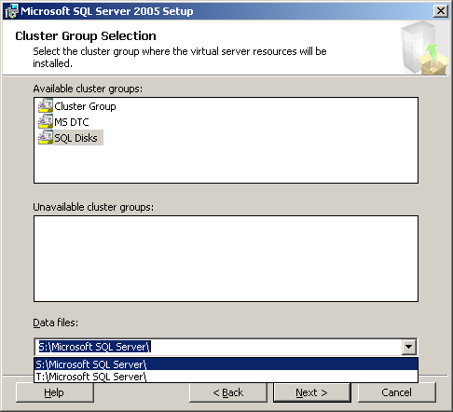

Select the required nodes to participate in the SQL Server cluster and click “Next”

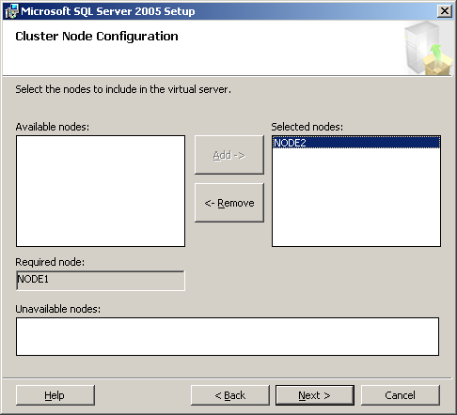

Supply an administrative account for the remote setup;

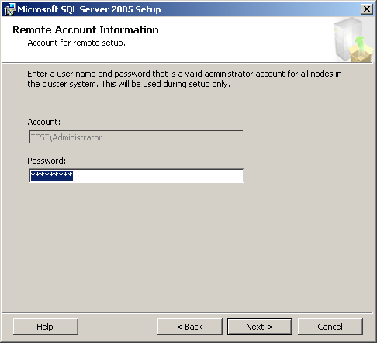

Switch to the domain controller and create a user account for the SQL Server service. Supply the service account information and click “Next”;

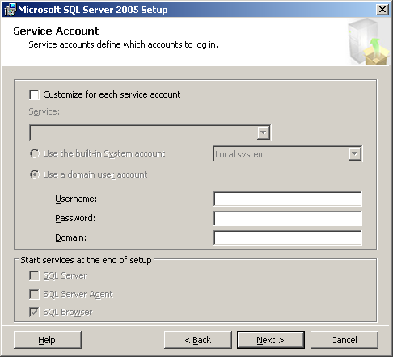
Switch to the domain controller and create a set of Global security groups for the SQL Server services. You may create a group for each resource indicated below, or create one group for all. The SQL Server service domain user account must be a member of the group(s). Supply the group name(s) and click “Next”;

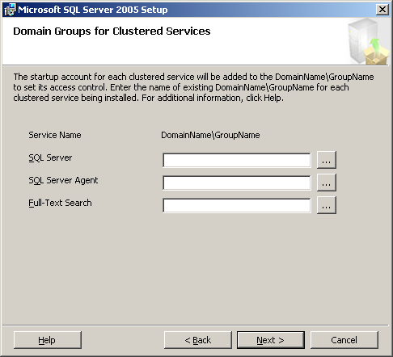

Select the SQL Server authentication method and click “Next”;

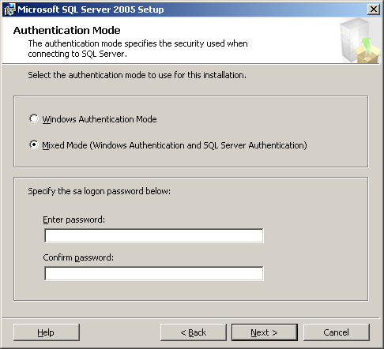
Select the SQL Server collation (if you set your Windows regional settings correctly you should see the following. Click “Next”;
Note If Latin1_General is not listed, the Regional Settings on the server are incorrect, stop the installation and check and correct the regional settings.

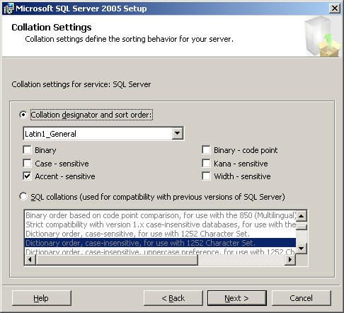

Click “Next”;

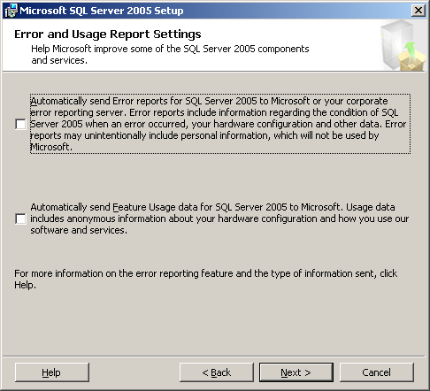

You are now ready to install;

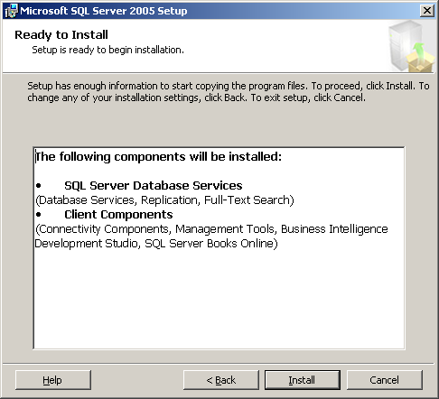

Setup displays the progress on each node via the drop down list indicated;

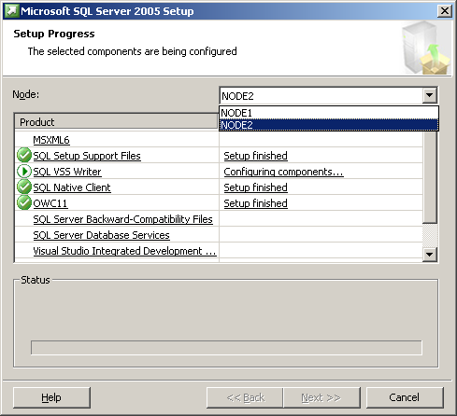

Once the installation has completed click “Next”;

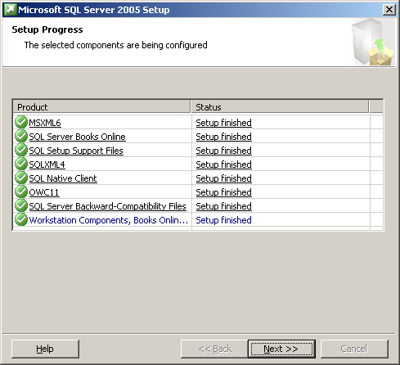

Click “Finish”.

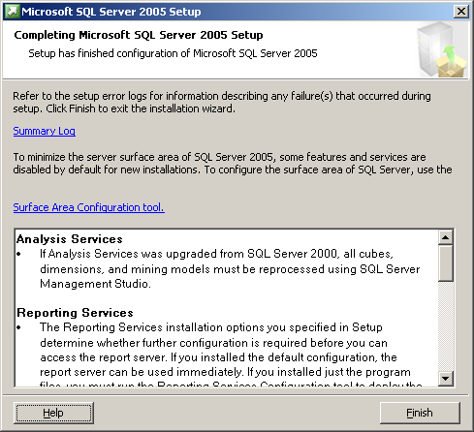

Appendix A Named Instances & network names
During SQL Server installation setup requires you to supply an instance name for the SQL Server instance you are installing. On a non clustered system, the machine name is the instance name prefix. A virtual network name is essentially the same as a machine name in that it must be unique on the network.

Installations of SQL Server allow only one default instance, after that the rest must be named.

Take the following scenarios

Non Clustered

A non clustered server named \\MYSERVER has 2 SQL Server instances installed to it. When the administrator installed SQL server they created a named instance using the name “Instance1” and a default instance.

To log on to each instance you would use,

Default

MYSERVER

Named

MYSERVER\Instance1

Clustered

A 2 node clustered system exists using the following details,

Node1 Node 2

Name = SQLCLNODE01 Name = SQLCLNODE02
IP = 10.10.10.17 IP = 10.10.10.18

Windows Cluster

Name = WINCL01
IP = 10.10.10.12

Default SQL Instance Named SQL Instance

Network Name = SQLCL01 Network Name = SQLCL02
Instance Name = Instance Name = INST01

You can see the complexity added to the system as there are now more names and IP addresses used for the same computers. In the clustered environment it is important to remember to disregard the node names and IP addresses when connecting to SQL Server. Everything is referenced by the Network name. In the clustered environment the Network Name and not the machine name forms the instances prefix.

To logon to the default instance you use

SQLCL01

To logon to the named instance you use

SQLCL01\INST01

Practice these by using names of your own to substitute the items above and ensure you understand default and named instances in both clustered and non clustered environments.

